8

Soil Desalinization and
Land Reclamation in Iran

A case study : Khuzistan Province

Ebrahim Pazira

Iranian Agricultural Engineering Research Institute (IAERI)

Karaj -Iran

Kouroush Sadeghzadeh

Iranian Agricultural Engineering Research Institute ( IAERI)

Karaj - Iran

Introduction

Land degradation is one of the most restrictive factor on world wide food production. In arid and semi-arid regions, apart from the water and wind erosion of valuable top- soils due to overgrazing and deforestation, the main factor contributing to land degradation and desertification is soil and water salinization. Salinization is the increase in concentration of total dissolved solutes in water and soil bulk solution. Soil and water resources can be salanized naturally by physical and chemical processes or by human activities (secondary salinization).

Secondary salinization is as old as the history of irrigation. The well known case of secondary salinization happened in Mesopotamia where the civilization establishment and development was based on irrigation farming and the main crop cultivated during the early days was wheat. Overirrigation along with improper management of irrigation facilities, poor soil internal drainage condition, unsuitable quality of irrigation water and lack of drainage facilities lead to accumulation of salts in irrigated lands. In response to these changes wheat was replaced by barley which is more salt - tolerant. By 1700 BC the cultivation of wheat had been abandoned completely (Ghassemi et al. 1995). Change of cultivation pattern lead to more and more salinization of land and water resources. Consequently, in the later millenniums the salinity of resources reached such levels that barley would not grow and the civilization of Summer and Akkad became depopulated and decadent. Other historic evidence from several parts of the world emphasis on the role of human- induced salinization on downfall of the civilizations.

Large scale irrigation developments, that come back decades ago, promoted soil and water salinization as well land degradation, particularly in arid and semi-arid zones. Now day, about 77 million hectares of cultivated lands are salt- affected to varying degrees from secondary salinization. Therefore, sustaining and preserving productivity of the current 230 million hectares of irrigated lands and 1475 million hectares of dry land agriculture is the basic concept. A typical example of irregular large scale irrigation developments is the Amu Darya and Syr Darya rivers in the Commonwealth of Idependent States(CIS) which diverted from the Aral sea for the development of irrigated lands in 1950s. Due to these huge diversions its level dropped about 13m and its area decreased by 40 per cent between 1960 and 1989 (Ghassemi et al. 1995). The Aral sea still is shrinking and this fully degraded the ecosystem and caused health hazards and climatic changes in the region.

Secondary salinization is predominant in arid and semi- arid regions. The countries affected by this phenomenon include: The United States of America, Argentina, Brazil, Chile, Peru, Australia, Thailand, China, India, Pakistan, Iran, Iraq, Turkey, Syria, Egypt and Spain. Table 1 provides global secondary salinization distribution in the world’s irrigated lands.

Table 9: Global estimate of secondary salinization
in the world’s irrigated lands.

Country | Cropped  Area  (Mha) | Irrigated  Area  (Mha) | Share of irrigated to cropped area  (per cent) | Salt affected land in irrigated Area (Mha) | Share of salt –affected to irrigated land (per cent)
China | 96.97 | 44.88 | 46.2 | 6.70 | 15.0
India | 168.99 | 42.10 | 24.9 | 7.00 | 16.6
Commonwealth of Independent States | 232.57 | 20.46 | 8.8 | 3.70 | 18.1
United States | 189.91 | 16.10 | 9.5 | 4.16 | 23.0
Pakistan | 20.76 | 16.08 | 77.5 | 4.22 | 26.2
Iran | 14.83 | 5.74 | 38.7 | 1.72 | 30.0
Thailand | 20.05 | 4.00 | 19.9 | 0.40 | 10.0
Egypt | 2.69 | 2.69 | 100.0 | 0.88 | 33.0
Australia | 47.11 | 1.83 | 3.9 | 0.16 | 8.7
Argentina | 35.75 | 1.72 | 4.8 | 0.58 | 33.7
South Africa | 13.17 | 1.13 | 8.6 | 0.10 | 8.9
Subtotal | 842.80 | 158.70 | 18.8 | 29.62 | 20.0
World | 1473.70 | 227.11 | 15.4 | 45.4 | 20.0
Source: Ghassemi et. Al (1995)

Salinity in Iran

The overincreasing salinity of land and water resources is one of the most important problems in Iran’s agriculture. The main factors on contributing to the salinity of soil and water resources of country include: high potential evapotranspiration, poor soil internal drainage condition, low rainfall and its improper seasonal and regional distribution, topographic situation creating closed and semi-closed basins, surface and subsurface drainage networks scarcity,overirrigation, irrigation with unsuitable water (surface and groundwater) and improper design, construction and management of irrigation facilities.

This factors lead to formation of vast saline and sodic soils which is distributed mostly in the central plateau, east and southwest parts of the country. However, some scattered regions in the north parts of the country suffer from the salinity and sodicity to varing degrees. It is believed that the total area of saline and sodic soils of Iran to be estimated about 24 million hectares or 15 per cent of the surface area of Iran (Pazira and Sadeghzadeh, 1998). Irrigation has predominant effects on the secondary salinization of land resources in the country. Considerable areas under the modern constructed dams have gone out of cultivation due to overirrigation, waterlogging and salinity problems (Bybordi, 1989). Consequently, the need for design, planning and construction of drainage networks has been recognized in nearly all modern irrigation projects. Also, in some irrigated as well as non-irrigated lands desalinization operations must be performed which is commonly time consuming and very expensive.
This paper presents an attempt to introduce some empirical relationships to quantify soil desalinization and land reclamation in Khuzistan provinc which is located in the southwest of Iran.

Methods and Materials

The selected site has typical condition ; the soil ranges from highly saline to highly saline-sodic and has heavy texture. The saline groundwater table is also shallow. Lowering of the groundwater table by means of open drains to a depth of 2.5 meters enables the determination of tile drain spacing which is essential for salt leaching as well as salt balance management. Subsurface drainage design was done for tile drain spacing of 25,50, 75, and 100 meters, all with 100 meters length. To compare the effect of tile drain spacing on soil desalinization and reclamation, 4 levels of depth of leaching water, i.e., 0.5, 1.0, 1.5 and 2.0 meters were applied in the same replication. Large size plots were designed. The top soils of the plots were plowed. Experiments were done on a field in which the tile drain spacing were different. Soil sampling depths and procedures, rate of water application and the water redistribution period were just the same. The soil salinity data obtained before and after leaching for eight different soil depths were used to calculate the mean depth values of soil segments from 0.5 to 2.0 meters down. The same statistical method was used to examine the obtained data. It can be seen that as the depth of leaching water or the ratio of leaching water to the depth of soil increases, the salt leaching rate also increases, specially in the topsoil layers. Also, the rate of salt leaching within the soil profile increases with an increase in depth of leaching water. However, in general, the mean depth values and the obtained results are nearly the same.

The salinity will be reduced only to a special rate (i.e.,Min ~ ECe = 2.0 dS/m) either under high or low application of leaching water. Therefore, it can be concluded that the reclamation requirement will be strongly related to the initial soil salt content and soil physical conditions rather than increase in depth of leaching water. Furthermore, it is worthy to use a unit depth of leaching water per unit depth of soil segment as the reclamation requirement and continue the salt leaching by irrigation through the principle of leaching requirement if leaching of soluble salts from the soil profile is our target. The calculated drain spacing may be suitable, but for waterlogging control and salt balance purposes the drain spacing may vary from 25 to 100 m in the region.

Soil Desalinization

The principle of desalinization consists of leaching out the soluble salts downward, specially from the top soil layers,using leaching water application as well as irrigation. Naturally, the percolated water contains much salts which should be removed by establishment of subsurface drainage systems, if the groundwater table is high. The presence of high saline water table causes the soil internal drainage condition to be insufficient and poor.

The data for soil salinity obtained before and after leaching experiments, were averaged for each treatment. The leaching curves with respect to soil desalinization at soil depths 0 - 0.1, 0-0.5, 0-1.0 and 0-1.5 meters are shown in Figure (6).

For similar experimental data Reeve (1957) has suggested to replace (Dlw) by (Dlw/DS), in the form of an empirical hyperbolic relationship as follows :
(Dlw/DS) = (ECi / 5EC f) + 0.15 (1)
In which Dlw is the depth of leaching water(cm, or m), DS is the depth of soil (cm,or m), ECi is the soil salinity (ECe, dS / m or salt % ) before leaching and ECf is the soil salinity ( ECe, dS / m or salt % ) after leaching.
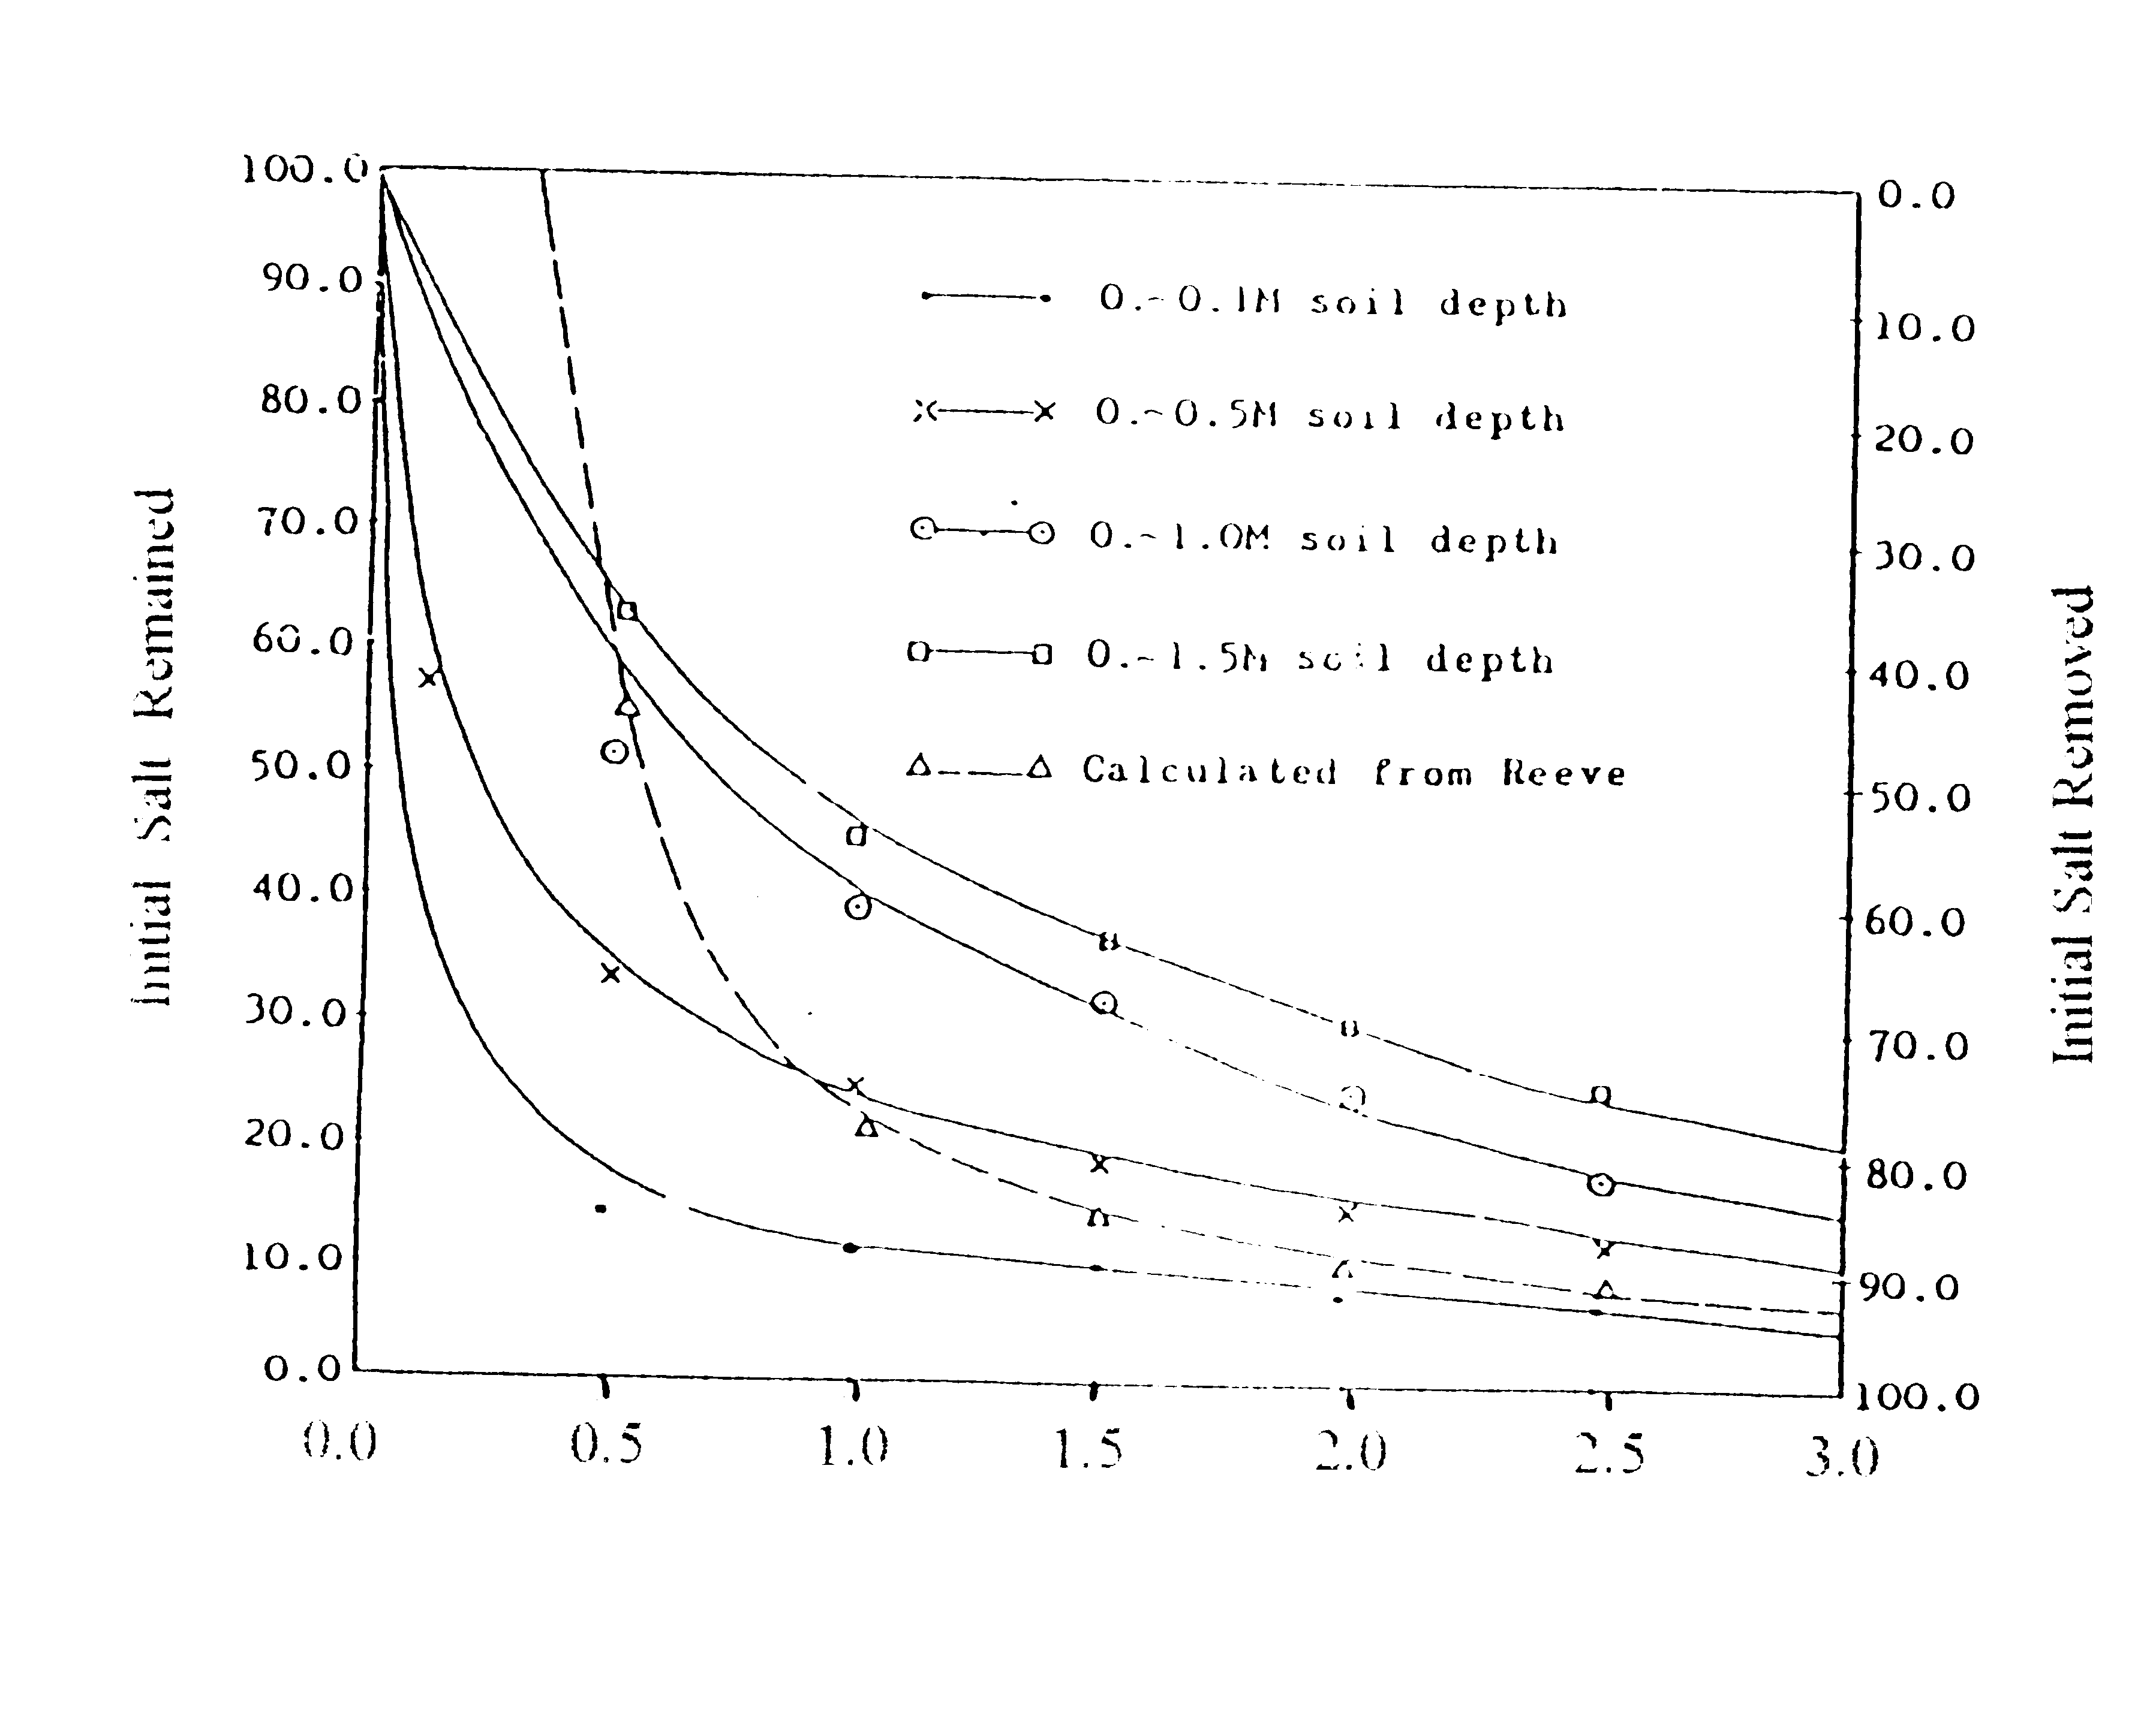
Depth of Leaching Water (Dlw) in Meter

Figure 6: Relation between soil salinity and depth of leaching water

In the case of DS= 1.0 meter, Eq.(1) was used where the results are given in Figure (7).
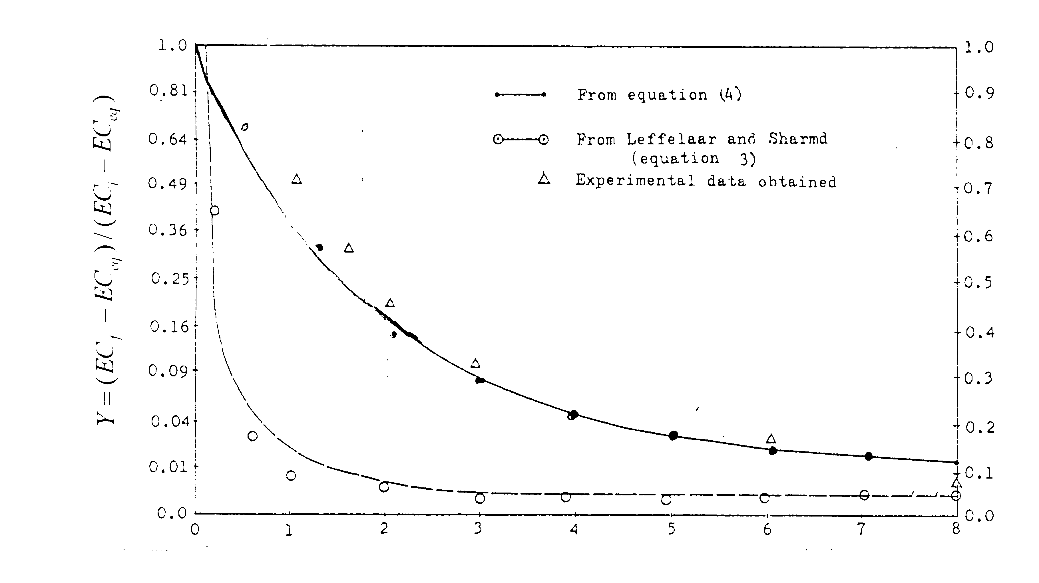
Depth of leaching water per unit depth of soil( DLw/DS )

Figure 7: Desalinization leaching curve

From the results, it could be seen that this equation can not be fitted to the leaching experimental data of Khuzistan province soils,because the natural conditions, initial salt content of soil and heaviness of soil texture, were different from Reeve’s experiments.

Van Hoorn (1973 ) and Leffelaar & Sharma (1977) reported opposite results using Eq. (1), even with rather the same soil texture (sandy loam to silt loam). However, from Figure (7) it can be seen that as the depth of leaching water increases, the rate of salt leaching also increases, specially at the top soil segments., (i ; e ;0.1 and 0.5 meter). As a result of this, the surface of bare experimental plots were plowed before leaching water application. In general, considering the soil segments of 0.5 and 1.0 meter as the top and sub soil layers, application of one unit of leaching water per unit depth of soil (two pore volume) decreases the initial salt content of the respective soil layers to 78% and 60%, respectively.

Desalinization Leaching Curve
The leaching graph could possibly show the relationship between soil EC${}_{i}$, EC${}_{f}$ and Dlw, as well as (ECf -ECeq) / ( Eci -ECeq) and Dlw, in which ${\text{EC}}_{\text{eq}}$ represents the salinity or electrical conductivity of soil extract obtained after salinity of that has come to an equilibrium under specified local conditions. Based on the relationship suggested by Reeve (1957), the following equation can be derived:
$\frac{({\text{EC}}_{f}−\text{ECeq})}{({\text{EC}}_{i}−\text{ECeq})}=A({\text{DS}}/{\text{Dlw}})+B$ (2)
where A and B are experimental constants. Leffelaar and Sharma (1977) used these empirical hyperbolic relationships in their treated cases ( sandy loam to silty loam soils ) as follows :

$({\text{EC}}_{f}−{{\text{EC}}_{\text{eq}}}/{{\text{EC}}_{i}}−{\text{EC}}_{\text{eq}})=0\text{.}\text{062}({\text{DS}}/{\text{Dlw}})+0\text{.}\text{034}$ (3)
The value of ${\text{EC}}_{\text{eq}}$ of Khuzistan soils in this report was found to be 2.0 ${\text{dSm}}^{−1}$ in top soil layer ( in traditional farms with good soil drainage conditions). This value, as mentioned by Dieleman (1963 ), depends mainly on evaporation, drainage conditions, and salinity of irrigation water (ECw). If this value is subtracted from ECf and ECi , the relationship between (ECf -ECeq ) / (EC i-ECeq ) and depth of leaching water becomes independent of salinity of leaching or irrigation water, existing drainage and evaporation conditions. The graphs that result from using the former relationship are determined by the soil characteristics.

The case study was conducted in summer season, when there was no rainfall and the rate of evaporation was excluded. In other cases, the depth of water which was needed for moistening the soil layer, was obtained by subtracting evaporation and adding rainfall. For soils which were used in this study ,the data of Figure (7) were used and attempt was also made to express the results using equation (3). The derived equation is as follows ;

$({\text{EC}}_{i}−{\text{EC}}_{\text{eq}})/({\text{EC}}_{f}−{\text{EC}}_{\text{eq}})=0\text{.}\text{0761}({\text{DS}}/{\text{Dlw}})+0\text{.}\text{023}$ (4)

The results of calculation based on Eqs. (3) and (4), and the experimental data are presented in Figure (7).From this, it can be seen that Eq. (4) fits accurately to the experimental data. However, equation (3) does not fit the experimental data obtained from this area, because of the heaviness of soil texture.

Comparison of Other Experimental Data

There are some theoretical models that predict the leaching curve such as the Glueckauf theory of column operation as applied to the soil by Van der Molen (1956), leaching theory of Dieleman (1963) and many numerical methods, as one was introduced by Tarkeltoub and Babcock (1971). Since there are some limitations as regards to their applicability to heavy and very heavy textured soils, the comparison was avoided. Comparison to other experimental desalinization leaching curves obtained in Iran (Khuzistan and Ahu- Char ) and Iraq (Annanah and Dujailah ) is presented in Figure(8). The data of Annanah and Dujailah were from Dieleman (1963), those of Ahu- Char experimental station were prepared by Van Aart and Osterkamp (1968) and those of Khuzistan experiments are from author’s research works.

From Figure (8) which shows a comparison between desalinization leaching curves for Khuzistan soils and those of Ahu- Char, Annanah and Dujailah soils, it will be shown that the leaching process on Khuzistan soils seems to be difficult, as compared with Ahu- Char soils in Iran and Dujailah in Iraq. It must be said that, experimental desalinization leaching curve is valid only for the initial salinity ranges through the soil profile. The values (electrical conductivity of saturated extract ) for Ahu - Char, Dujailah, Annanah and Khuzistan soils were 30-140, 40-100, 20-60, and 65-80, respectively. This is the reason why the initial salt leaching was less effective for Khuzistan and Annanah soils as compared to other soils.

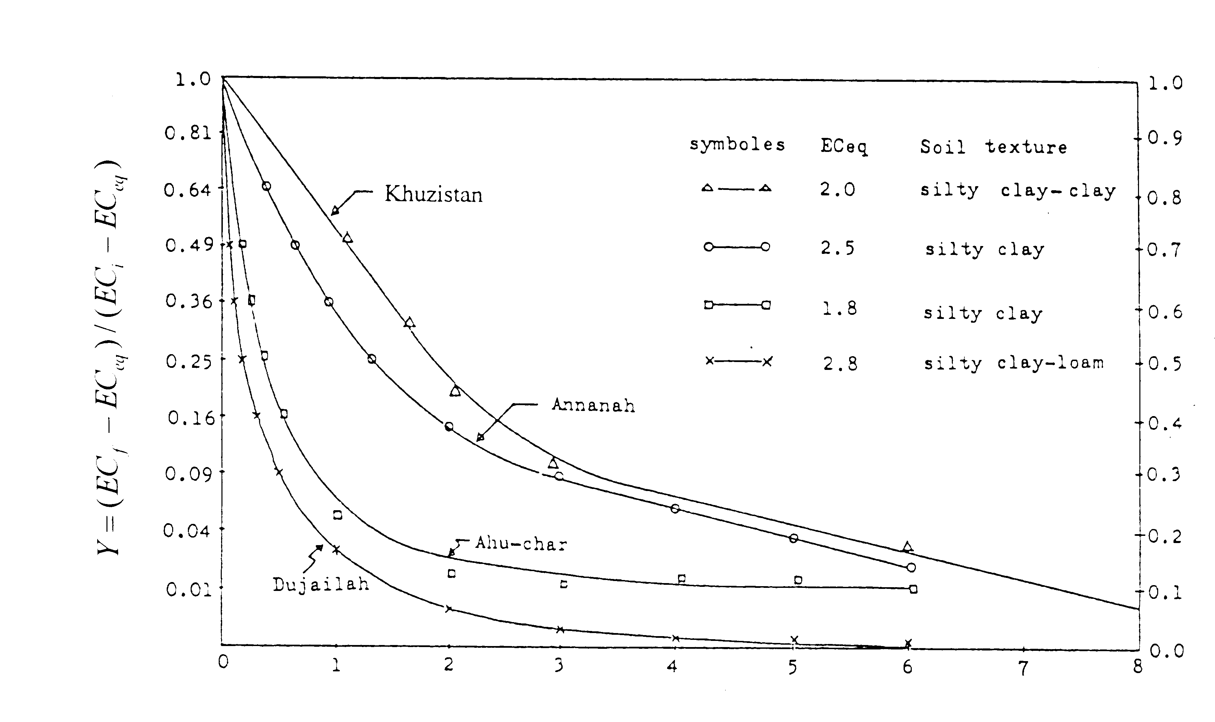
Depth of Leaching Water Per Depth of Soil (DLw/Ds)

Figure 8: Desalinization leaching curves for the Khuzistan soils

Another reason for less effectiveness of leaching on Khuzistan soils, which is characterized by heavy and very heavy textured soils, is that the leaching water which passed through the large pores (cracks, which were in the soil column and/or had developed quickly on soil surface during the redistribution period ) had only a minor effect and hence decreased leaching efficiency.

Application of Salt Leaching Curve

Leaching practices and programming can be conducted in some different ways. The main difference in the leaching methods depends on whether application of leaching water will be done on bare soil or it will be programmed by cropping systems. Consequently, selection of appropriate method for soil salt leaching not only depends on soil physico - chemical properties, but also on social and economical aspects. However, based on mentioned considerations, a specified reclamation procedure seems to be advisable. Moreover, the use of leaching curves will enable us to arrange the various steps of accurate planning in relation to reclamation water requirement as well as the time needed for completion of reclamation procedure.

Conclusions

Studies on the salinity problem in Iran, in general, and Khuzistan plains in detail were considered in this research. As it could be pictured soil salinity, sodicity and waterlogging problems are the main causes of deterioration of the irrigated lands and crop yield reduction in Iran. It is important to note that extension of irrigated area by means of construction of storage and diversion dams caused serious problems and deterioration of the irrigated lands in the country. This deterioration was enhanced when the groundwater table was relatively shallow ; capillary action and upward movement of water from saline groundwater table made the soil completely unarable. To reclaim such a potential productive lands additional water was needed for leaching process. Since water was not available each year a noticeable area is shifting out of cultivation. A typical example of such problems happened in the area of the Khuzistan plain; the details, causes as well as the solution of the problems are presented. In reclamation process of the saline, and saline - sodic soils,some approaches such as subsurface drainage networks planning and construction, salt leaching operations and amendments application must be recognized and utilized. Good soil drainage conditions, effective irrigation and proper cropping systems are important to improve and maintain the productivity of the reclaimed irrigable lands. Continuous inspection is needed for irrigation of reclaimed lands ; if any problem happens, the solution should be studied. Still much more research works are needed in this respect.

References

Bybordi, M. 1989. Problems in planning of irrigation projects in Iran. In J. R. Rydzewski and C. F. ward (eds.). Irrigation: theory and practice. Proceedings of the International Conference held at the University of Southhampton, 12-15 September.
Dieleman, P.J. 1963. Reclamation of salt - affected soils in Iraq. I.L.R.I., No.11, Wageningen, The Netherlands.
Ghassemi, F., A. J. Jakeman and H. A. Nix.1995. Salinisation of land and water resources. Centre for Resource and Environmental Studies. The Australian National University. Canberra ACT 0200. Australia.
Leffelaar, P. A. and P. Sharma.1977. Leaching of highly saline sodic soil. J. of hydrl. 32 : 203-218.
Pazira, E. and K. Sadeghzadeh. 1998. National review document on optimizing soil and water use in Iran. Workshop of ICISAT, Sahelian Center. Niamy,Niger, 13-18 April.
Reeve, R. C. 1975. The relation of salinity to irrigation and drainage requirement. 3rd Cong. on Irrigation and Drainage. Tran.5 : 157-187.
Van Aart, R. and J. L. Oasterkamp. 1968. Interim report on soil reclamation in Iran. No. 203. Soil and Water Research Institute of Iran.
Van der Molen, H. W.; 1956. Desalinization of saline soils as a column process. Soil Sci. 81:19-27.

